SPI:

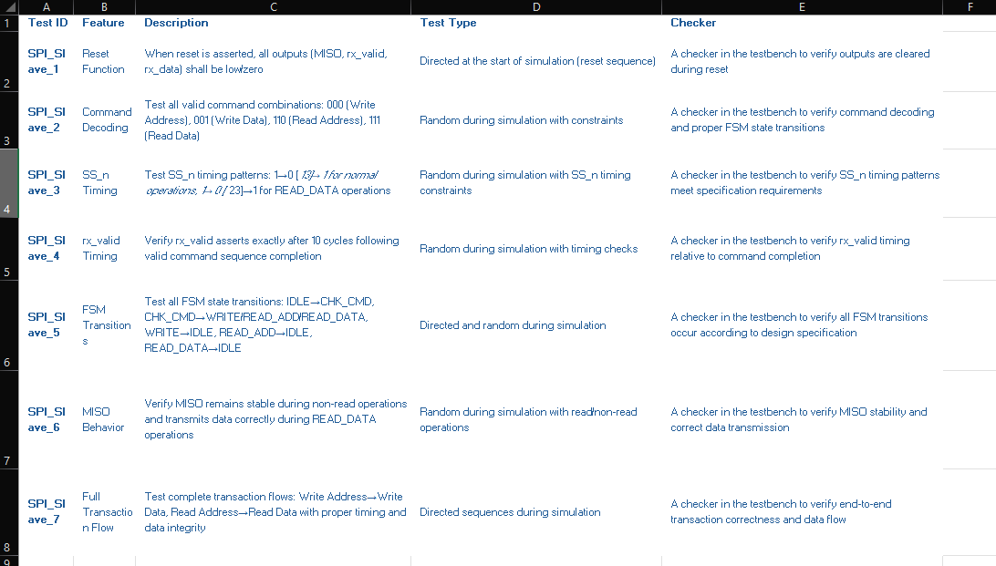
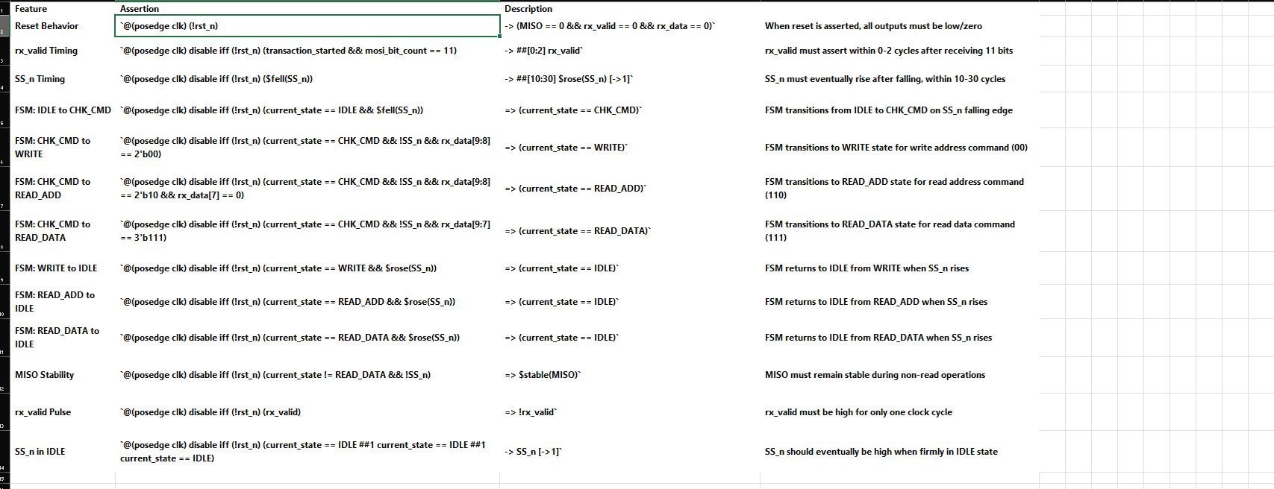
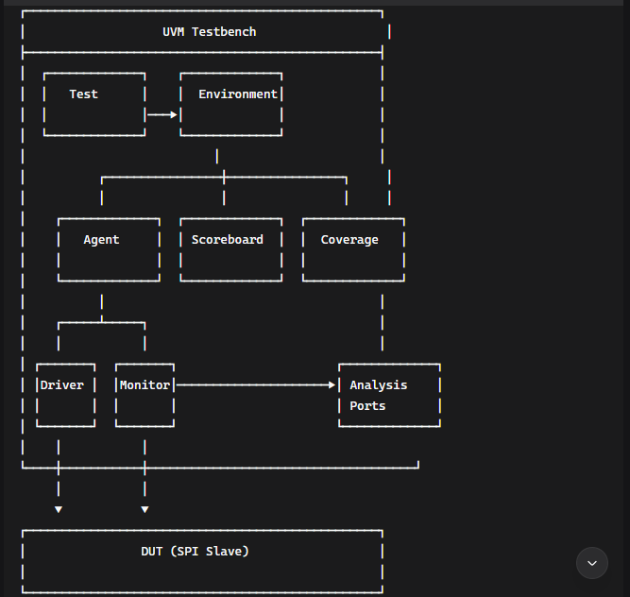
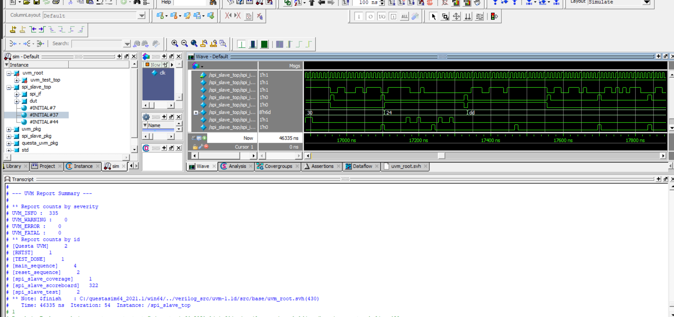
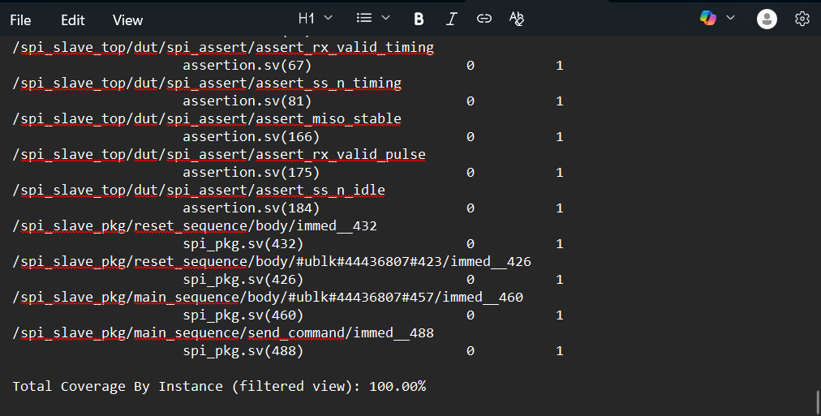
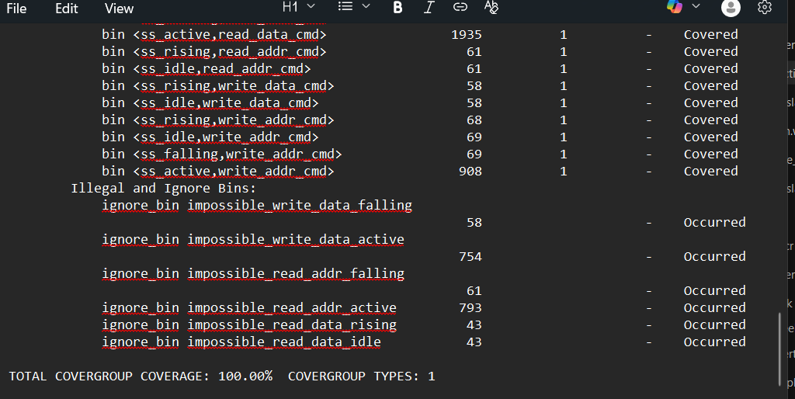

UVM Testbench Operation Summary

The UVM testbench operates through a structured flow: Test → Sequences → Driver → DUT → Monitor → Scoreboard/Coverage.

Initialization: The test builds the environment and configures virtual interfaces. Reset sequence initializes the DUT.

Execution: Main sequence generates constrained random transactions with valid SPI commands (000, 001, 110, 111) and proper SS_n timing (13 cycles normal, 23 cycles read data). Driver serializes data and controls SPI signals.

Monitoring: Monitor captures DUT responses and sends to scoreboard for checking and coverage collector for tracking functional coverage.

Verification: Scoreboard validates behavior, coverage tracks completion metrics, and assertions monitor protocol compliance in real-time. The testbench achieves 100% coverage through targeted sequences and comprehensive checking.

Results: Final report shows pass/fail status and coverage achievement, ensuring complete SPI Slave verification.

Codes:
- Interface
interface spi_slave_if (input bit clk);
logic rst_n;
logic MOSI;
logic SS_n;
logic tx_valid;
logic [7:0] tx_data;
logic MISO;
logic rx_valid;
logic [9:0] rx_data;

// Clocking block for driver
clocking driver_cb @(posedge clk);
default input #1 output #1;
output rst_n;
output MOSI;
output SS_n;
output tx_valid;
output tx_data;
input MISO;
input rx_valid;
input rx_data;
endclocking

// Clocking block for monitor
clocking monitor_cb @(posedge clk);
default input #1 output #1;
input rst_n;
input MOSI;
input SS_n;
input tx_valid;
input tx_data;
input MISO;
input rx_valid;
input rx_data;
endclocking

modport DRIVER (clocking driver_cb, input clk);
modport MONITOR (clocking monitor_cb, input clk);

endinterface

- Assertions
module spi_slave_assertions(
input clk,
input rst_n,
input MOSI,
input SS_n,
input MISO,
input rx_valid,
input [9:0] rx_data,
input [2:0] current_state
);

// Parameter definitions for FSM states
parameter IDLE = 3'b000;
parameter CHK_CMD = 3'b001;
parameter WRITE = 3'b010;
parameter READ_ADD = 3'b011;
parameter READ_DATA = 3'b100;

// ============================================================
// Assertion 1: Reset behavior - outputs must be cleared
// ============================================================
property reset_outputs_p;
@(posedge clk) (!rst_n) |-> (MISO == 0 && rx_valid == 0 && rx_data == 0);
endproperty

assert_reset_outputs: assert property (reset_outputs_p)
else $error("ASSERTION FAILED: Outputs not cleared during reset - MISO=%b, rx_valid=%b, rx_data=%h",
MISO, rx_valid, rx_data);

// ============================================================
// Assertion 2: rx_valid timing after valid command sequence
// FIXED: Proper bit counting and timing check
// ============================================================

// Track complete 11-bit MOSI data reception
int mosi_bit_count = 0;
bit transaction_started = 0;

always @(posedge clk) begin
if (!rst_n) begin
mosi_bit_count <= 0;
transaction_started <= 0;
end else begin
// Detect transaction start (SS_n falling edge)
if ($fell(SS_n)) begin
transaction_started <= 1;
mosi_bit_count <= 0;
end
// Count bits while SS_n is low and transaction is active
else if (!SS_n && transaction_started) begin
mosi_bit_count <= mosi_bit_count + 1;
end
// Reset on transaction end
else if (SS_n) begin
transaction_started <= 0;
mosi_bit_count <= 0;
end
end
end

// rx_valid should assert after receiving 11 bits (at cycle 11 or 12)
property rx_valid_timing_p;
@(posedge clk) disable iff (!rst_n)
(transaction_started && mosi_bit_count == 11) |-> ##[0:2] rx_valid;
endproperty

assert_rx_valid_timing: assert property (rx_valid_timing_p)
else $error("ASSERTION FAILED: rx_valid did not assert after 11-bit MOSI data reception");

// ============================================================
// Assertion 2b: SS_n behavior validation
// Simplified: Just check that SS_n toggles appropriately
// ============================================================

// SS_n should eventually go high after being low
property ss_n_eventually_high_p;
@(posedge clk) disable iff (!rst_n)
($fell(SS_n)) |-> ##[10:30] $rose(SS_n) [->1];
endproperty

assert_ss_n_timing: assert property (ss_n_eventually_high_p)
else $warning("ASSERTION WARNING: SS_n did not rise after falling edge");

// ============================================================
// Assertion 3: FSM Transition Checks (Conditional Compilation)
// ============================================================
`ifdef SIM
// 3a: IDLE to CHK_CMD transition when SS_n falls
property idle_to_chk_cmd_p;
@(posedge clk) disable iff (!rst_n)
(current_state == IDLE && $fell(SS_n)) |=> (current_state == CHK_CMD);
endproperty

assert_idle_to_chk_cmd: assert property (idle_to_chk_cmd_p)
else $error("FSM ASSERTION FAILED: IDLE to CHK_CMD transition violated");

// 3b: CHK_CMD to WRITE (when receiving 00x command)
property chk_cmd_to_write_p;
@(posedge clk) disable iff (!rst_n)
(current_state == CHK_CMD && !SS_n && rx_data[9:8] == 2'b00)
|=> (current_state == WRITE);
endproperty

assert_chk_cmd_to_write: assert property (chk_cmd_to_write_p)
else $error("FSM ASSERTION FAILED: CHK_CMD to WRITE transition violated");

// 3c: CHK_CMD to READ_ADD (when receiving 110 command)
property chk_cmd_to_read_add_p;
@(posedge clk) disable iff (!rst_n)
(current_state == CHK_CMD && !SS_n && rx_data[9:8] == 2'b10 && rx_data[7] == 0)
|=> (current_state == READ_ADD);
endproperty

assert_chk_cmd_to_read_add: assert property (chk_cmd_to_read_add_p)
else $error("FSM ASSERTION FAILED: CHK_CMD to READ_ADD transition violated");

// 3d: CHK_CMD to READ_DATA (when receiving 111 command)
property chk_cmd_to_read_data_p;
@(posedge clk) disable iff (!rst_n)
(current_state == CHK_CMD && !SS_n && rx_data[9:7] == 3'b111)
|=> (current_state == READ_DATA);
endproperty

assert_chk_cmd_to_read_data: assert property (chk_cmd_to_read_data_p)
else $error("FSM ASSERTION FAILED: CHK_CMD to READ_DATA transition violated");

// 3e: WRITE to IDLE when SS_n rises
property write_to_idle_p;
@(posedge clk) disable iff (!rst_n)
(current_state == WRITE && $rose(SS_n)) |=> (current_state == IDLE);
endproperty

assert_write_to_idle: assert property (write_to_idle_p)
else $error("FSM ASSERTION FAILED: WRITE to IDLE transition violated");

// 3f: READ_ADD to IDLE when SS_n rises
property read_add_to_idle_p;
@(posedge clk) disable iff (!rst_n)
(current_state == READ_ADD && $rose(SS_n)) |=> (current_state == IDLE);
endproperty

assert_read_add_to_idle: assert property (read_add_to_idle_p)
else $error("FSM ASSERTION FAILED: READ_ADD to IDLE transition violated");

// 3g: READ_DATA to IDLE when SS_n rises
property read_data_to_idle_p;
@(posedge clk) disable iff (!rst_n)
(current_state == READ_DATA && $rose(SS_n)) |=> (current_state == IDLE);
endproperty

assert_read_data_to_idle: assert property (read_data_to_idle_p)
else $error("FSM ASSERTION FAILED: READ_DATA to IDLE transition violated");

`endif

// ============================================================
// Additional Useful Assertions
// ============================================================

// MISO should be stable during non-read operations
property miso_stable_p;
@(posedge clk) disable iff (!rst_n)
(current_state != READ_DATA && !SS_n) |=> $stable(MISO);
endproperty

assert_miso_stable: assert property (miso_stable_p)
else $warning("MISO changed during non-READ_DATA state");

// rx_valid should only be high for one cycle
property rx_valid_one_cycle_p;
@(posedge clk) disable iff (!rst_n)
(rx_valid) |=> !rx_valid;
endproperty

assert_rx_valid_pulse: assert property (rx_valid_one_cycle_p)
else $warning("rx_valid remained high for more than one cycle");

// SS_n behavior in IDLE: When firmly in IDLE state, SS_n should eventually be high
property ss_n_idle_p;
@(posedge clk) disable iff (!rst_n)
(current_state == IDLE ##1 current_state == IDLE ##1 current_state == IDLE) |-> SS_n [->1] ;
endproperty

assert_ss_n_idle: assert property (ss_n_idle_p)
else $warning("SS_n should be high when firmly in IDLE state");

endmodule

- Packages:
package spi_slave_pkg;
import uvm_pkg::*;
`include "uvm_macros.svh"

// ==========================================================================
// Sequence Item
// ==========================================================================
class spi_slave_seq_item extends uvm_sequence_item;
`uvm_object_utils(spi_slave_seq_item)

rand bit rst_n;
rand bit [10:0] MOSI_data;
rand bit [7:0] tx_data;
rand bit is_read_data;

// Outputs
bit MISO;
bit rx_valid;
bit [9:0] rx_data;
bit SS_n;
bit tx_valid;

// Constraint 1: Reset deasserted most of the time
constraint rst_c {
rst_n dist {1 := 95, 0 := 5};
}

// Constraint 3: Valid command combinations
constraint mosi_cmd_c {
MOSI_data[10:8] inside {3'b000, 3'b001, 3'b110, 3'b111};
}

// Better distribution for coverage
constraint cmd_dist_c {
MOSI_data[10:8] dist {
3'b000 := 30, // Write Address
3'b001 := 25, // Write Data
3'b110 := 25, // Read Address
3'b111 := 20 // Read Data
};
}

function new(string name = "spi_slave_seq_item");
super.new(name);
endfunction

function void post_randomize();
is_read_data = (MOSI_data[10:8] == 3'b111);
tx_valid = is_read_data;
endfunction

endclass

// ==========================================================================
// Sequencer
// ==========================================================================
typedef uvm_sequencer#(spi_slave_seq_item) spi_slave_sequencer;

// ==========================================================================
// Driver
// ==========================================================================
class spi_slave_driver extends uvm_driver#(spi_slave_seq_item);
`uvm_component_utils(spi_slave_driver)

virtual spi_slave_if vif;

function new(string name = "spi_slave_driver", uvm_component parent = null);
super.new(name, parent);
endfunction

function void build_phase(uvm_phase phase);
super.build_phase(phase);
if(!uvm_config_db#(virtual spi_slave_if)::get(this, "", "spi_slave_vif", vif))
`uvm_fatal(get_type_name(), "Virtual interface not found")
endfunction

task run_phase(uvm_phase phase);
vif.rst_n <= 1;
vif.SS_n <= 1;
vif.MOSI <= 0;
vif.tx_valid <= 0;
vif.tx_data <= 0;
@(posedge vif.clk);

forever begin
seq_item_port.get_next_item(req);
drive_transaction(req);
seq_item_port.item_done();
end
endtask

task drive_transaction(spi_slave_seq_item item);
bit [2:0] cmd = item.MOSI_data[10:8];
int active_cycles;

if (!item.rst_n) begin
@(negedge vif.clk);
vif.rst_n <= 0;
vif.SS_n <= 1;
vif.MOSI <= 0;
vif.tx_valid <= 0;
repeat(3) @(posedge vif.clk);
vif.rst_n <= 1;
@(posedge vif.clk);
return;
end

active_cycles = (cmd == 3'b111) ? 22 : 12;

// Cycle 1: SS_n HIGH
vif.SS_n <= 1;
vif.tx_valid <= 0;
vif.MOSI <= 0;
@(posedge vif.clk);

// Start transaction: SS_n goes LOW
vif.SS_n <= 0;

if (cmd == 3'b111) begin
vif.tx_valid <= 1;
vif.tx_data <= item.tx_data;
end else begin
vif.tx_valid <= 0;
end
@(posedge vif.clk);

// Drive 11 bits serially
for (int i = 10; i >= 0; i--) begin
vif.MOSI <= item.MOSI_data[i];
@(posedge vif.clk);
end

// Extended cycles for read data
if (cmd == 3'b111) begin
repeat(10) @(posedge vif.clk);
end else begin
@(posedge vif.clk);
end

endtask

endclass

// ==========================================================================
// Monitor - ENHANCED for better cross coverage tracking
// ==========================================================================
class spi_slave_monitor extends uvm_monitor;
`uvm_component_utils(spi_slave_monitor)

virtual spi_slave_if vif;
uvm_analysis_port#(spi_slave_seq_item) mon_ap;
bit prev_SS_n;
bit [9:0] last_rx_data;

function new(string name = "spi_slave_monitor", uvm_component parent = null);
super.new(name, parent);
endfunction

function void build_phase(uvm_phase phase);
super.build_phase(phase);
if(!uvm_config_db#(virtual spi_slave_if)::get(this, "", "spi_slave_vif", vif))
`uvm_fatal(get_type_name(), "Virtual interface not found")
mon_ap = new("mon_ap", this);
endfunction

task run_phase(uvm_phase phase);
spi_slave_seq_item item;
prev_SS_n = 1;

forever begin
item = spi_slave_seq_item::type_id::create("item");

@(posedge vif.clk);

item.rst_n = vif.rst_n;
item.SS_n = vif.SS_n;
item.tx_valid = vif.tx_valid;
item.tx_data = vif.tx_data;
item.MISO = vif.MISO;
item.rx_valid = vif.rx_valid;
item.rx_data = vif.rx_data;

// Track command during transaction
if (vif.rx_valid) begin
last_rx_data = vif.rx_data;
item.MOSI_data[10:8] = vif.rx_data[9:8];
item.is_read_data = (vif.rx_data[9:8] == 2'b11);
end else if (!vif.SS_n && prev_SS_n) begin
// Falling edge detected - use last known command
item.rx_data = last_rx_data;
end

prev_SS_n = vif.SS_n;

mon_ap.write(item);
end
endtask

endclass

// ==========================================================================
// Agent
// ==========================================================================
class spi_slave_agent extends uvm_agent;
`uvm_component_utils(spi_slave_agent)

spi_slave_driver drv;
spi_slave_monitor mon;
spi_slave_sequencer sqr;

function new(string name = "spi_slave_agent", uvm_component parent = null);
super.new(name, parent);
endfunction

function void build_phase(uvm_phase phase);
super.build_phase(phase);
drv = spi_slave_driver::type_id::create("drv", this);
mon = spi_slave_monitor::type_id::create("mon", this);
sqr = spi_slave_sequencer::type_id::create("sqr", this);
endfunction

function void connect_phase(uvm_phase phase);
super.connect_phase(phase);
drv.seq_item_port.connect(sqr.seq_item_export);
endfunction

endclass

// ==========================================================================
// Scoreboard
// ==========================================================================
class spi_slave_scoreboard extends uvm_scoreboard;
`uvm_component_utils(spi_slave_scoreboard)

uvm_analysis_imp#(spi_slave_seq_item, spi_slave_scoreboard) sb_imp;
int pass_count, fail_count;

function new(string name = "spi_slave_scoreboard", uvm_component parent = null);
super.new(name, parent);
endfunction

function void build_phase(uvm_phase phase);
super.build_phase(phase);
sb_imp = new("sb_imp", this);
endfunction

function void write(spi_slave_seq_item item);
if (!item.rst_n) begin
if (item.MISO == 0 && item.rx_valid == 0 && item.rx_data == 0) begin
pass_count++;
end else begin
fail_count++;
`uvm_error(get_type_name(), $sformatf("FAIL: Outputs not cleared during reset"))
end
end

if (item.rx_valid && item.rst_n) begin
`uvm_info(get_type_name(), $sformatf("Transaction: rx_data=%0h (%s)",
item.rx_data,
item.rx_data[9:8] == 2'b00 ? "WRITE_ADDR" :
item.rx_data[9:8] == 2'b01 ? "WRITE_DATA" :
item.rx_data[9:8] == 2'b10 ? "READ_ADDR" : "READ_DATA"), UVM_MEDIUM)
pass_count++;
end
endfunction

function void report_phase(uvm_phase phase);
super.report_phase(phase);
`uvm_info(get_type_name(), $sformatf("\n=== SCOREBOARD SUMMARY ===\nPass: %0d | Fail: %0d",
pass_count, fail_count), UVM_LOW)
endfunction

endclass

// ==========================================================================
// Coverage Collector - FIXED for 100% coverage
// ==========================================================================
class spi_slave_coverage extends uvm_subscriber#(spi_slave_seq_item);
`uvm_component_utils(spi_slave_coverage)

spi_slave_seq_item item;
bit prev_SS_n = 1;
bit [1:0] current_cmd;

covergroup spi_cov;
option.per_instance = 1;

// REQUIREMENT 1: rx_data[9:8] values and transitions
rx_data_cp: coverpoint item.rx_data[9:8] iff (item.rx_valid && item.rst_n) {
bins write_addr = {2'b00};
bins write_data = {2'b01};
bins read_addr = {2'b10};
bins read_data = {2'b11};
bins transitions = (2'b00 => 2'b01 => 2'b10 => 2'b11);
}

// REQUIREMENT 2: SS_n timing patterns
ss_n_transaction_cp: coverpoint item.rx_data[9:8] iff (item.rx_valid && item.rst_n) {
bins normal_write_addr = {2'b00};
bins normal_write_data = {2'b01};
bins normal_read_addr = {2'b10};
bins extended_read_data = {2'b11};
}

// ENHANCED: Track SS_n state for cross coverage
ss_n_state_cp: coverpoint item.SS_n iff (item.rst_n) {
bins ss_active = {0};
bins ss_idle = {1};
bins ss_falling = (1 => 0);
bins ss_rising = (0 => 1);
}

// REQUIREMENT 3: MOSI command validation
mosi_cmd_cp: coverpoint current_cmd iff (item.rst_n) {
bins write_addr_cmd = {2'b00};
bins write_data_cmd = {2'b01};
bins read_addr_cmd = {2'b10};
bins read_data_cmd = {2'b11};
}

// REQUIREMENT 4: Cross coverage - FIXED
// Sample during any SS_n state when we have valid command info
ss_mosi_cross: cross ss_n_state_cp, mosi_cmd_cp iff (item.rst_n) {
// Only ignore truly impossible combinations
ignore_bins impossible_read_data_idle = binsof(ss_n_state_cp.ss_idle) && binsof(mosi_cmd_cp.read_data_cmd);
ignore_bins impossible_read_data_rising = binsof(ss_n_state_cp.ss_rising) && binsof(mosi_cmd_cp.read_data_cmd);
ignore_bins impossible_read_addr_active = binsof(ss_n_state_cp.ss_active) && binsof(mosi_cmd_cp.read_addr_cmd);
ignore_bins impossible_read_addr_falling = binsof(ss_n_state_cp.ss_falling) && binsof(mosi_cmd_cp.read_addr_cmd);
ignore_bins impossible_write_data_active = binsof(ss_n_state_cp.ss_active) && binsof(mosi_cmd_cp.write_data_cmd);
ignore_bins impossible_write_data_falling = binsof(ss_n_state_cp.ss_falling) && binsof(mosi_cmd_cp.write_data_cmd);
}

endgroup

function new(string name = "spi_slave_coverage", uvm_component parent = null);
super.new(name, parent);
spi_cov = new();
endfunction

function void write(spi_slave_seq_item t);
item = t;

// Update current command when rx_valid
if (item.rx_valid) begin
current_cmd = item.rx_data[9:8];
end

// Sample coverage every cycle
spi_cov.sample();

prev_SS_n = item.SS_n;
endfunction

function void report_phase(uvm_phase phase);
real total_cov = spi_cov.get_coverage();
`uvm_info(get_type_name(), $sformatf("\n=== FUNCTIONAL COVERAGE ===\nTotal: %.2f%%\nrx_data: %.2f%%\nss_n_trans: %.2f%%\nss_n_state: %.2f%%\nmosi_cmd: %.2f%%\ncross: %.2f%%",
total_cov,
spi_cov.rx_data_cp.get_coverage(),
spi_cov.ss_n_transaction_cp.get_coverage(),
spi_cov.ss_n_state_cp.get_coverage(),
spi_cov.mosi_cmd_cp.get_coverage(),
spi_cov.ss_mosi_cross.get_coverage()), UVM_LOW)
endfunction

endclass

// ==========================================================================
// Environment
// ==========================================================================
class spi_slave_env extends uvm_env;
`uvm_component_utils(spi_slave_env)

spi_slave_agent agt;
spi_slave_scoreboard sb;
spi_slave_coverage cov;

function new(string name = "spi_slave_env", uvm_component parent = null);
super.new(name, parent);
endfunction

function void build_phase(uvm_phase phase);
super.build_phase(phase);
agt = spi_slave_agent::type_id::create("agt", this);
sb = spi_slave_scoreboard::type_id::create("sb", this);
cov = spi_slave_coverage::type_id::create("cov", this);
endfunction

function void connect_phase(uvm_phase phase);
super.connect_phase(phase);
agt.mon.mon_ap.connect(sb.sb_imp);
agt.mon.mon_ap.connect(cov.analysis_export);
endfunction

endclass

// ==========================================================================
// Base Sequence
// ==========================================================================
class spi_slave_base_seq extends uvm_sequence#(spi_slave_seq_item);
`uvm_object_utils(spi_slave_base_seq)

function new(string name = "spi_slave_base_seq");
super.new(name);
endfunction

endclass

// ==========================================================================
// Reset Sequence
// ==========================================================================
class reset_sequence extends spi_slave_base_seq;
`uvm_object_utils(reset_sequence)

function new(string name = "reset_sequence");
super.new(name);
endfunction

task body();
spi_slave_seq_item item;

`uvm_info(get_type_name(), "Applying reset...", UVM_MEDIUM)

repeat(3) begin
item = spi_slave_seq_item::type_id::create("item");
start_item(item);
assert(item.randomize() with {rst_n == 0;});
finish_item(item);
end

item = spi_slave_seq_item::type_id::create("item");
start_item(item);
assert(item.randomize() with {rst_n == 1;});
finish_item(item);

`uvm_info(get_type_name(), "Reset completed", UVM_MEDIUM)

endtask

endclass

// ==========================================================================
// Main Sequence - ENHANCED for 100% coverage
// ==========================================================================
class main_sequence extends spi_slave_base_seq;
`uvm_object_utils(main_sequence)

function new(string name = "main_sequence");
super.new(name);
endfunction

task body();
spi_slave_seq_item item;

`uvm_info(get_type_name(), "Starting random transactions", UVM_MEDIUM)

// More random transactions for better coverage
repeat(150) begin
item = spi_slave_seq_item::type_id::create("item");
start_item(item);
assert(item.randomize() with {rst_n == 1;});
finish_item(item);
end

`uvm_info(get_type_name(), "Starting targeted sequences", UVM_MEDIUM)

// Multiple targeted sequences for transitions
repeat(15) begin
send_command(3'b000); // Write Address
send_command(3'b001); // Write Data
send_command(3'b110); // Read Address
send_command(3'b111); // Read Data
end

// Extra write address commands for falling edge coverage
`uvm_info(get_type_name(), "Ensuring falling edge coverage", UVM_MEDIUM)
repeat(20) begin
send_command(3'b000); // Write Address (most likely to hit falling)
end

`uvm_info(get_type_name(), "Main sequence completed", UVM_MEDIUM)

endtask

task send_command(bit [2:0] cmd);
spi_slave_seq_item item;
item = spi_slave_seq_item::type_id::create("item");
start_item(item);
assert(item.randomize() with {
rst_n == 1;
MOSI_data[10:8] == cmd;
});
finish_item(item);
endtask

endclass

// ==========================================================================
// Test
// ==========================================================================
class spi_slave_test extends uvm_test;
`uvm_component_utils(spi_slave_test)

spi_slave_env env;
reset_sequence rst_seq;
main_sequence main_seq;

function new(string name = "spi_slave_test", uvm_component parent = null);
super.new(name, parent);
endfunction

function void build_phase(uvm_phase phase);
super.build_phase(phase);
env = spi_slave_env::type_id::create("env", this);
endfunction

task run_phase(uvm_phase phase);
phase.raise_objection(this);

`uvm_info(get_type_name(), "\n========== SPI Slave Verification ==========", UVM_LOW)

rst_seq = reset_sequence::type_id::create("rst_seq");
rst_seq.start(env.agt.sqr);

main_seq = main_sequence::type_id::create("main_seq");
main_seq.start(env.agt.sqr);

#10000;
phase.drop_objection(this);
endtask

function void report_phase(uvm_phase phase);
uvm_report_server svr;
super.report_phase(phase);

svr = uvm_report_server::get_server();
if (svr.get_severity_count(UVM_FATAL) + svr.get_severity_count(UVM_ERROR) > 0) begin
`uvm_info(get_type_name(), "\n========== TEST FAILED ==========", UVM_NONE)
end else begin
`uvm_info(get_type_name(), "\n========== TEST PASSED ==========", UVM_NONE)
end
endfunction

endclass

endpackage

- Top module
module spi_slave_top;

import uvm_pkg::*;
import spi_slave_pkg::*;

bit clk;
initial begin
clk = 0;
forever #5 clk = ~clk;
end

spi_slave_if spi_if(clk);

SPI_Slave dut (
.clk(spi_if.clk),
.rst_n(spi_if.rst_n),
.MOSI(spi_if.MOSI),
.SS_n(spi_if.SS_n),
.tx_valid(spi_if.tx_valid),
.tx_data(spi_if.tx_data),
.MISO(spi_if.MISO),
.rx_valid(spi_if.rx_valid),
.rx_data(spi_if.rx_data)
);

bind SPI_Slave spi_slave_assertions spi_assert (
.clk(clk),
.rst_n(rst_n),
.MOSI(MOSI),
.SS_n(SS_n),
.MISO(MISO),
.rx_valid(rx_valid),
.rx_data(rx_data),
.current_state(current)
);

initial begin
uvm_config_db#(virtual spi_slave_if)::set(null, "*", "spi_slave_vif", spi_if);
$dumpfile("spi_slave.vcd");
$dumpvars(0, spi_slave_top);
run_test("spi_slave_test");
end

initial begin
#100000;
$display("ERROR: Simulation timeout!");
$finish;
end

endmodule

RAM:

Design Analysis:
- Bugs found in design
  - Case (2’b11): changed to read address
  - Expanded the condition during the assignment for tx to avoid conflict with rst_n condition, so now it also checks the rst_n.
- RAM UVM Testbench Operation Summar
  - Initialization: Test builds environment and retrieves virtual interface via config DB. All sequences (reset, write_only, read_only, write_read) are instantiated.
  - Execution: Reset sequence initializes DUT. Write-read sequence generates constrained transactions with command ordering: Write Address→Write Data and Read Address→Read Data sequences with 60/40 probability distribution.
  - Verification: Driver applies signals to DUT via interface. Monitor captures responses and sends to scoreboard for data integrity checking and coverage collector for tracking functional coverage (command values, transitions, and cross coverage).
  - Completion: Scoreboard reports pass/fail results, coverage shows completion metrics, and assertions monitor protocol compliance in real-time. Objection mechanism controls test duration.
  - Single Port Ram to be used as golden model: The golden model established in design, was the single port ram designed in the project for the design part of the diploma.
- Verification Plan
Label | Design Requirement Description | Stimulus Generation | Functional Coverage | Functionality Check
REQ_1 | Verify reset functionality — all outputs and addresses should be cleared when rst_n = 0. | Drive rst_n = 0 while toggling clk, randomize din, rx_valid values, then deassert reset. | Coverpoint on rst_n transition 1 → 0 → 1. Check bins for dout, tx_valid being 0 after reset. | Scoreboard compares DUT and golden model after reset; all outputs must match initial state (zeros).
REQ_2 | Verify write address load operation (din[9:8] = 2'b00). | Generate transactions with din[9:8]=2'b00 and randomized lower bits [7:0] (address). | Coverpoint on din[9:8] with bins {00,01,10,11}. Cross din[9:8] with rx_valid=1. | Check scoreboard/golden model receives same address; DUT must store new write address correctly.
REQ_3 | Verify write data operation (din[9:8] = 2'b01) writes data to previously stored address. | Generate sequence of write address followed by write data with randomized data [7:0]. | Cover ordering: write_addr → write_data. Coverpoint for number of unique addresses written. | Compare memory contents (MEM[addr]) in DUT vs golden model after each write transaction.
REQ_4 | Verify read address load operation (din[9:8] = 2'b10). | Generate transactions setting read address using random [7:0] values. | Coverpoint for din[9:8]=2'b10 and unique address reads. | Ensure next read data (2’b11) accesses correct stored address in both DUT and golden model.
REQ_5 | Verify read data operation (din[9:8] = 2'b11) outputs correct data and sets tx_valid. | Generate transaction pattern: write_addr → write_data → read_addr → read_data. | Cross coverage between din[9:8] and tx_valid=1. Check all 4 operation codes used. | Scoreboard compares dout vs dout_ref and tx_valid vs tx_valid_ref. Must match for all transactions.
REQ_6 | Verify transaction ordering correctness. | Generate random valid/invalid sequences; include out-of-order operations. | Sequence coverage: valid order (WA→WD→RA→RD) vs invalid (WD→RA, etc.). | DUT and golden model should differ only for invalid sequences (expected error behavior).
REQ_7 | Verify continuous read/write operations without reset in between. | Back-to-back random transactions without asserting reset. | Coverpoint for consecutive valid operations (rx_valid high multiple cycles). | DUT and golden model outputs must remain consistent under back-to-back operation.
REQ_8 | Verify no output activity when rx_valid=0. | Randomize idle cycles with rx_valid=0. | Cross rx_valid=0 with tx_valid, expecting no active bins. | Scoreboard ensures no memory or output updates occur during idle cycles.

- Assertion Table:
Feature | Assertion
Reset behavior: Whenever reset (rst_n) is deasserted, outputs dout and tx_valid must be 0. | `@(posedge clk) (!r_if.rst_n)
Input phase (address/write/read setup): For operations 00, 01, 10, tx_valid should remain low. | `@(posedge clk) disable iff(!r_if.rst_n) (r_if.din[9:8] inside {2'b00,2'b01,2'b10})
Output phase (read data operation): When operation is 2’b11 and rx_valid is high, tx_valid must assert in the next cycle. | `@(posedge clk) disable iff(!r_if.rst_n) (r_if.din[9:8]==2'b11 && r_if.rx_valid)
Write sequence ordering: Write data (01) must occur after write address (00). | `@(posedge clk) disable iff(!r_if.rst_n) (r_if.din[9:8]==2'b00)
Read sequence ordering: Read data (11) must occur after read address (10). | `@(posedge clk) disable iff(!r_if.rst_n) (r_if.din[9:8]==2'b10)

- Coverage Reports:
================================Statement Details================================

Statement Coverage for instance /\top#dut --

Line Item Count Source
---- ---- ----- ------
File RAM.sv
2 module RAM (RAM_if r_if);
3
4 reg [7:0] MEM [255:0];
5
6 reg [7:0] Rd_Addr, Wr_Addr;
7
8 1 10011 always @(posedge r_if.clk) begin
9 if (~r_if.rst_n) begin
10 1 489 r_if.dout <= 0;
11 1 489 r_if.tx_valid <= 0;
12 1 489 Rd_Addr <= 0;
13 1 489 Wr_Addr <= 0;
14 end
15 else
16 if (r_if.rx_valid) begin
17 case (r_if.din[9:8])
18 1 3079 2'b00 : Wr_Addr <= r_if.din[7:0];
19 1 1521 2'b01 : MEM[Wr_Addr] <= r_if.din[7:0];
20 1 2966 2'b10 : Rd_Addr <= r_if.din[7:0];
21 1 1491 2'b11 : r_if.dout <= MEM[Rd_Addr]; //changed to read address
22 1 ***0*** default : r_if.dout <= 0;
23 endcase
24 end
25
26 1 10011 r_if.tx_valid <= (r_if.din[9] && r_if.din[8] && r_if.rx_valid && r_if.rst_n)? 1'b1 : 1'b0;

Toggle Coverage:
Enabled Coverage Bins Hits Misses Coverage
---------------- ---- ---- ------ --------
Toggles 32 32 0 100.00%

================================Toggle Details================================

Toggle Coverage for instance /\top#dut --

Node 1H->0L 0L->1H "Coverage"
---------------------------------------
Rd_Addr[0-7] 1 1 100.00
Wr_Addr[0-7] 1 1 100.00

Total Node Count = 16
Toggled Node Count = 16
Untoggled Node Count = 0

Toggle Coverage = 100.00% (32 of 32 bins)

Coverage Report by instance with details

=================================================================================
=== Instance: /top/dut/RAM_assertions_inst
=== Design Unit: work.RAM_assertions
=================================================================================

Directive Coverage:
Directives 5 5 0 100.00%

DIRECTIVE COVERAGE:
--------------------------------------------------------------------------------------------
Name Design Design Lang File(Line) Hits Status
Unit UnitType
--------------------------------------------------------------------------------------------
/top/dut/RAM_assertions_inst/cover__read_sequence_check
RAM_assertions Verilog SVA RAM_assertions.sv(38)
2866 Covered
/top/dut/RAM_assertions_inst/cover__write_sequence_check
RAM_assertions Verilog SVA RAM_assertions.sv(31)
2954 Covered
/top/dut/RAM_assertions_inst/cover__output_assert
RAM_assertions Verilog SVA RAM_assertions.sv(24)
1423 Covered
/top/dut/RAM_assertions_inst/cover__input_assert
RAM_assertions Verilog SVA RAM_assertions.sv(17)
7581 Covered
/top/dut/RAM_assertions_inst/cover__reset_assert
RAM_assertions Verilog SVA RAM_assertions.sv(10)
32 Covered

=================================================================================
=== Instance: /RAM_coverage_pkg
=== Design Unit: work.RAM_coverage_pkg
=================================================================================

Covergroup Coverage:
Covergroups 1 na na 100.00%
Coverpoints/Crosses 5 na na na
Covergroup Bins 27 27 0 100.00%
----------------------------------------------------------------------------------------------------------
Covergroup Metric Goal Bins Status

----------------------------------------------------------------------------------------------------------
TYPE /RAM_coverage_pkg/RAM_coverage/cvr_grp 100.00% 100 - Covered
covered/total bins: 27 27 -
missing/total bins: 0 27 -
% Hit: 100.00% 100 -
Coverpoint cp_op 100.00% 100 - Covered
covered/total bins: 7 7 -
missing/total bins: 0 7 -
% Hit: 100.00% 100 -
Coverpoint cp_rx 100.00% 100 - Covered
covered/total bins: 2 2 -
missing/total bins: 0 2 -
% Hit: 100.00% 100 -
Coverpoint cp_tx 100.00% 100 - Covered
covered/total bins: 2 2 -
missing/total bins: 0 2 -
% Hit: 100.00% 100 -
Cross cross_op_rx 100.00% 100 - Covered
covered/total bins: 8 8 -
missing/total bins: 0 8 -
% Hit: 100.00% 100 -
Cross cross_rd_tx 100.00% 100 - Covered
covered/total bins: 8 8 -
missing/total bins: 0 8 -
% Hit: 100.00% 100 -
Covergroup instance \/RAM_coverage_pkg::RAM_coverage::cvr_grp
100.00% 100 - Covered
covered/total bins: 27 27 -
missing/total bins: 0 27 -
% Hit: 100.00% 100 -
Coverpoint cp_op 100.00% 100 - Covered
covered/total bins: 7 7 -
missing/total bins: 0 7 -
% Hit: 100.00% 100 -
bin wr_addr 1761 1 - Covered
bin wr_data 791 1 - Covered
bin rd_addr 1667 1 - Covered
bin rd_data 786 1 - Covered
bin wr_addr_to_wr_data 426 1 - Covered
bin rd_addr_to_rd_data 393 1 - Covered
bin wr_rd_sequence 33 1 - Covered
Coverpoint cp_rx 100.00% 100 - Covered
covered/total bins: 2 2 -
missing/total bins: 0 2 -
% Hit: 100.00% 100 -
bin r_valid_low 242 1 - Covered
bin r_valid_high 4763 1 - Covered
Coverpoint cp_tx 100.00% 100 - Covered
covered/total bins: 2 2 -
missing/total bins: 0 2 -
% Hit: 100.00% 100 -
bin t_valid_low 4231 1 - Covered
bin t_valid_high 774 1 - Covered
Cross cross_op_rx 100.00% 100 - Covered
covered/total bins: 8 8 -
missing/total bins: 0 8 -
% Hit: 100.00% 100 -
Auto, Default and User Defined Bins:
bin cross_when_valid 4763 1 - Covered
bin <wr_rd_sequence,r_valid_low> 1 1 - Covered
bin <rd_addr_to_rd_data,r_valid_low> 12 1 - Covered
bin <wr_addr_to_wr_data,r_valid_low> 19 1 - Covered
bin <rd_data,r_valid_low> 31 1 - Covered
bin <wr_data,r_valid_low> 37 1 - Covered
bin <rd_addr,r_valid_low> 81 1 - Covered
bin <wr_addr,r_valid_low> 93 1 - Covered
Cross cross_rd_tx 100.00% 100 - Covered
covered/total bins: 8 8 -
missing/total bins: 0 8 -
% Hit: 100.00% 100 -
Auto, Default and User Defined Bins:
bin rddata_txvalid 774 1 - Covered
bin <wr_rd_sequence,t_valid_low> 33 1 - Covered
bin <rd_addr_to_rd_data,t_valid_low> 393 1 - Covered
bin <wr_addr_to_wr_data,t_valid_low> 426 1 - Covered
bin <rd_data,t_valid_low> 786 1 - Covered
bin <wr_data,t_valid_low> 791 1 - Covered
bin <rd_addr,t_valid_low> 893 1 - Covered
bin <wr_addr,t_valid_low> 1761 1 - Covered

COVERGROUP COVERAGE:
----------------------------------------------------------------------------------------------------------
Covergroup Metric Goal Bins Status

----------------------------------------------------------------------------------------------------------
TYPE /RAM_coverage_pkg/RAM_coverage/cvr_grp 100.00% 100 - Covered
covered/total bins: 27 27 -
missing/total bins: 0 27 -
% Hit: 100.00% 100 -
Coverpoint cp_op 100.00% 100 - Covered
covered/total bins: 7 7 -
missing/total bins: 0 7 -
% Hit: 100.00% 100 -
Coverpoint cp_rx 100.00% 100 - Covered
covered/total bins: 2 2 -
missing/total bins: 0 2 -
% Hit: 100.00% 100 -
Coverpoint cp_tx 100.00% 100 - Covered
covered/total bins: 2 2 -
missing/total bins: 0 2 -
% Hit: 100.00% 100 -
Cross cross_op_rx 100.00% 100 - Covered
covered/total bins: 8 8 -
missing/total bins: 0 8 -
% Hit: 100.00% 100 -
Cross cross_rd_tx 100.00% 100 - Covered
covered/total bins: 8 8 -
missing/total bins: 0 8 -
% Hit: 100.00% 100 -
Covergroup instance \/RAM_coverage_pkg::RAM_coverage::cvr_grp
100.00% 100 - Covered
covered/total bins: 27 27 -
missing/total bins: 0 27 -
% Hit: 100.00% 100 -
Coverpoint cp_op 100.00% 100 - Covered
covered/total bins: 7 7 -
missing/total bins: 0 7 -
% Hit: 100.00% 100 -
bin wr_addr 1761 1 - Covered
bin wr_data 791 1 - Covered
bin rd_addr 1667 1 - Covered
bin rd_data 786 1 - Covered
bin wr_addr_to_wr_data 426 1 - Covered
bin rd_addr_to_rd_data 393 1 - Covered
bin wr_rd_sequence 33 1 - Covered
Coverpoint cp_rx 100.00% 100 - Covered
covered/total bins: 2 2 -
missing/total bins: 0 2 -
% Hit: 100.00% 100 -
bin r_valid_low 242 1 - Covered
bin r_valid_high 4763 1 - Covered
Coverpoint cp_tx 100.00% 100 - Covered
covered/total bins: 2 2 -
missing/total bins: 0 2 -
% Hit: 100.00% 100 -
bin t_valid_low 4231 1 - Covered
bin t_valid_high 774 1 - Covered
Cross cross_op_rx 100.00% 100 - Covered
covered/total bins: 8 8 -
missing/total bins: 0 8 -
% Hit: 100.00% 100 -
Auto, Default and User Defined Bins:
bin cross_when_valid 4763 1 - Covered
bin <wr_rd_sequence,r_valid_low> 1 1 - Covered
bin <rd_addr_to_rd_data,r_valid_low> 12 1 - Covered
bin <wr_addr_to_wr_data,r_valid_low> 19 1 - Covered
bin <rd_data,r_valid_low> 31 1 - Covered
bin <wr_data,r_valid_low> 37 1 - Covered
bin <rd_addr,r_valid_low> 81 1 - Covered
bin <wr_addr,r_valid_low> 93 1 - Covered
Cross cross_rd_tx 100.00% 100 - Covered
covered/total bins: 8 8 -
missing/total bins: 0 8 -
% Hit: 100.00% 100 -
Auto, Default and User Defined Bins:
bin rddata_txvalid 774 1 - Covered
bin <wr_rd_sequence,t_valid_low> 33 1 - Covered
bin <rd_addr_to_rd_data,t_valid_low> 393 1 - Covered
bin <wr_addr_to_wr_data,t_valid_low> 426 1 - Covered
bin <rd_data,t_valid_low> 786 1 - Covered
bin <wr_data,t_valid_low> 791 1 - Covered
bin <rd_addr,t_valid_low> 893 1 - Covered
bin <wr_addr,t_valid_low> 1761 1 - Covered

TOTAL COVERGROUP COVERAGE: 100.00% COVERGROUP TYPES: 1

DIRECTIVE COVERAGE:
--------------------------------------------------------------------------------------------
Name Design Design Lang File(Line) Hits Status
Unit UnitType
--------------------------------------------------------------------------------------------
/top/dut/RAM_assertions_inst/cover__read_sequence_check
RAM_assertions Verilog SVA RAM_assertions.sv(38)
2866 Covered
/top/dut/RAM_assertions_inst/cover__write_sequence_check
RAM_assertions Verilog SVA RAM_assertions.sv(31)
2954 Covered
/top/dut/RAM_assertions_inst/cover__output_assert
RAM_assertions Verilog SVA RAM_assertions.sv(24)
1423 Covered
/top/dut/RAM_assertions_inst/cover__input_assert
RAM_assertions Verilog SVA RAM_assertions.sv(17)
7581 Covered
/top/dut/RAM_assertions_inst/cover__reset_assert
RAM_assertions Verilog SVA RAM_assertions.sv(10)
32 Covered

TOTAL DIRECTIVE COVERAGE: 100.00% COVERS: 5

Total Coverage By Instance (filtered view): 100.00%

Screenshots:
- UVM Report
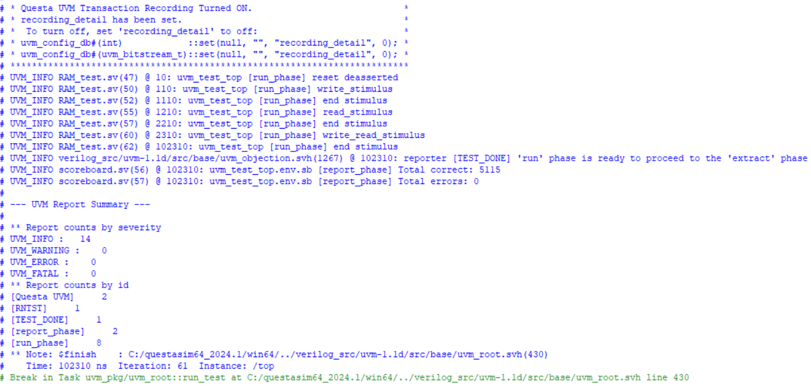
- Coverage:
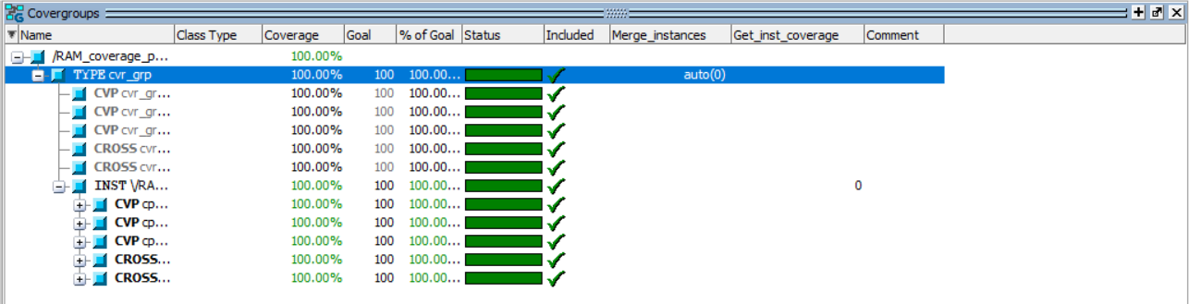

- Assertions:
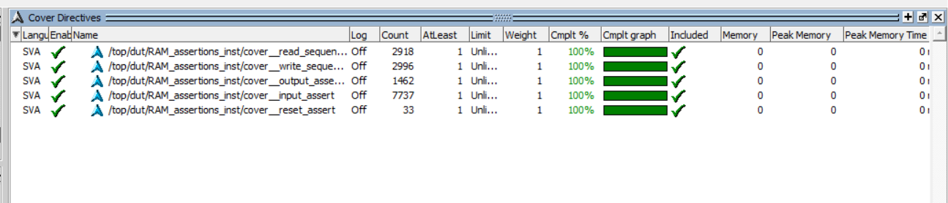
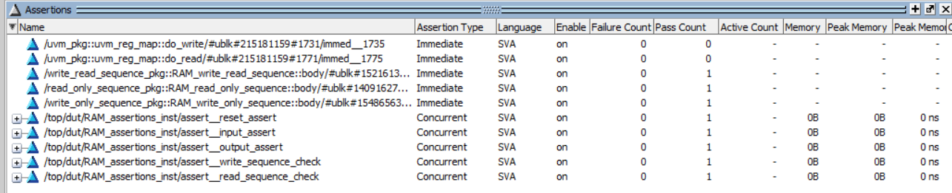
- Waveform
  - Random snippet
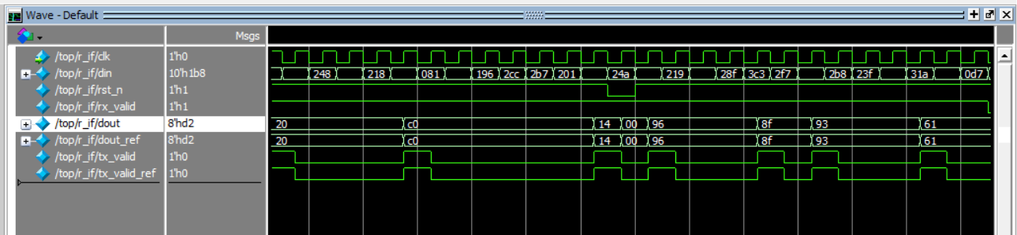
  - Reset sequence
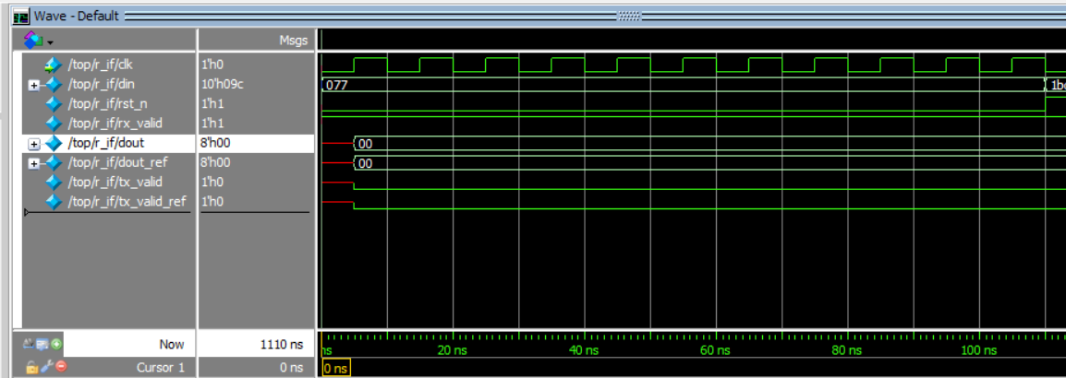

  - Write Only
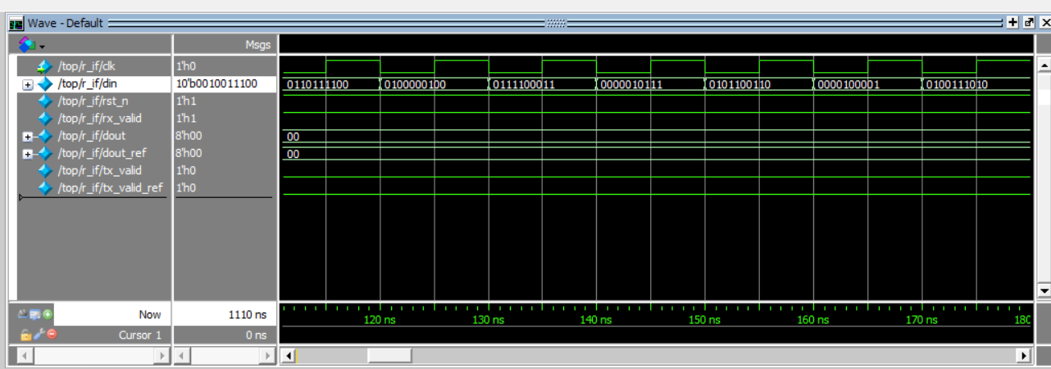
  - Read Only
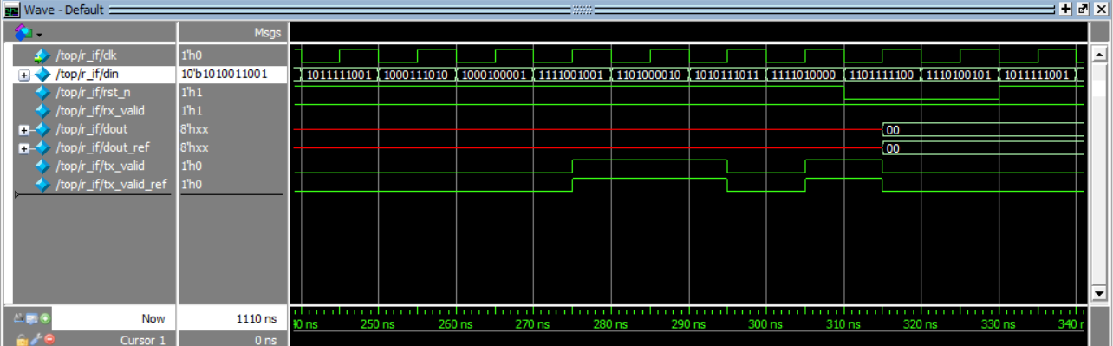
  - Write Read
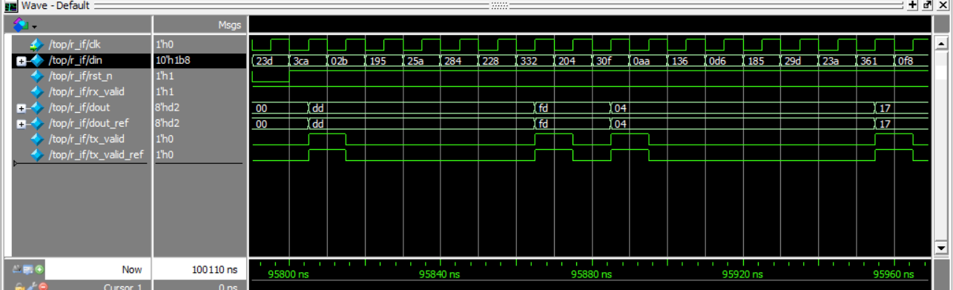

Codes:
- Run.do
vlib work
vlog -f src_files.list
vsim -voptargs=+acc work.top -classdebug -uvmcontrol=all
add wave /top/r_if/*
run -all
- Src_file.list
RAM_coverage.sv
scoreboard.sv
monitor.sv
agent.sv
RAM_seq_item.sv
RAM_sequencer.sv
reset_sequence.sv
write_only_sequence.sv
read_only_sequence.sv
write_read_sequence.sv
RAM_config.sv
RAM_driver.sv
RAM_env.sv
RAM_test.sv
RAM.sv
SinglePort_SRAM.v
RAM_if.sv
RAM_assertions.sv
top.sv
- RAM coverage
package RAM_coverage_pkg;

import uvm_pkg::*;
import RAM_seq_item_pkg::*;
import RAM_sequencer_pkg::*;
import monitor_pkg::*;
`include "uvm_macros.svh"

class RAM_coverage extends uvm_component;

`uvm_component_utils(RAM_coverage)
uvm_analysis_export #(RAM_seq_item) cov_export;
uvm_tlm_analysis_fifo #(RAM_seq_item) cov_fifo;
RAM_seq_item seq_item_cov;

covergroup cvr_grp;
cp_op : coverpoint seq_item_cov.din[9:8] {
bins wr_addr = {2'b00};
bins wr_data = {2'b01};
bins rd_addr = {2'b10};
bins rd_data = {2'b11};

// transition bins
bins wr_addr_to_wr_data = (2'b00 => 2'b01);
bins rd_addr_to_rd_data = (2'b10 => 2'b11);
bins wr_rd_sequence = (2'b00 => 2'b01 => 2'b10 => 2'b11);
}

cp_rx : coverpoint seq_item_cov.rx_valid {
bins r_valid_low = {1'b0};
bins r_valid_high = {1'b1};
}

cp_tx : coverpoint seq_item_cov.tx_valid {
bins t_valid_low = {1'b0};
bins t_valid_high = {1'b1};
}

// cross: din[9:8] x rx_valid (only need the rx_valid high in the cross)
cross_op_rx : cross cp_op, cp_rx {
bins cross_when_valid = binsof(cp_op) && binsof(cp_rx.r_valid_high);
}

// cross: when din == read_data (2'b11) cross tx_valid==1
cross_rd_tx : cross cp_op, cp_tx {
bins rddata_txvalid = binsof(cp_op) && binsof(cp_tx.t_valid_high);
}
endgroup

function new(string name = "RAM_coverage", uvm_component parent = null);
super.new(name, parent);
cvr_grp = new();
endfunction

function void build_phase(uvm_phase phase);
super.build_phase(phase);
cov_export = new("cov_export", this);
cov_fifo = new("cov_fifo", this);
endfunction

function void connect_phase(uvm_phase phase);
super.connect_phase(phase);
cov_export.connect(cov_fifo.analysis_export);
endfunction

task run_phase(uvm_phase phase);
super.run_phase(phase);
forever begin
cov_fifo.get(seq_item_cov);
cvr_grp.sample();
end
endtask

endclass

endpackage

- Scoreboard
package RAM_scoreboard_pkg;

import uvm_pkg::*;
import RAM_seq_item_pkg::*;
import RAM_sequencer_pkg::*;
import monitor_pkg::*;
`include "uvm_macros.svh"

class RAM_scoreboard extends uvm_scoreboard;
`uvm_component_utils(RAM_scoreboard)
uvm_analysis_export #(RAM_seq_item) sb_export;
uvm_tlm_analysis_fifo #(RAM_seq_item) sb_fifo;
RAM_seq_item seq_item_sb;
logic signed [5:0] out_ref;

int error_count = 0;
int correct_count = 0;

function new(string name = "RAM_scoreboard", uvm_component parent = null);
super.new(name, parent);
endfunction

function void build_phase(uvm_phase phase);
super.build_phase(phase);
sb_export = new("sb_export", this);
sb_fifo = new("sb_fifo", this);
endfunction

function void connect_phase(uvm_phase phase);
super.connect_phase(phase);
sb_export.connect(sb_fifo.analysis_export);
endfunction

task run_phase(uvm_phase phase);
super.run_phase(phase);
forever begin
sb_fifo.get(seq_item_sb);
ref_model(seq_item_sb);

if (seq_item_sb.dout != seq_item_sb.dout_ref || seq_item_sb.tx_valid != seq_item_sb.tx_valid_ref) begin
`uvm_info("run_phase", $sformatf("Comparison unsuccessful, transaction: %s",
seq_item_sb.convert2string()), UVM_HIGH)
error_count++;
end else begin
correct_count++;
end
end
endtask

task ref_model(RAM_seq_item seq_item_chk);

endtask

function void report_phase(uvm_phase phase);
super.report_phase(phase);
`uvm_info("report_phase", $sformatf("Total correct: %0d", correct_count), UVM_MEDIUM);
`uvm_info("report_phase", $sformatf("Total errors: %0d", error_count), UVM_MEDIUM);
endfunction

endclass

endpackage

- Monitor
package monitor_pkg;

import uvm_pkg::*;
import RAM_seq_item_pkg::*;
`include "uvm_macros.svh"

class monitor extends uvm_monitor;

`uvm_component_utils(monitor)
virtual RAM_if RAM_vif;
RAM_seq_item rsp_seq_item;
uvm_analysis_port #(RAM_seq_item) mon_ap;

function new(string name = "monitor", uvm_component parent = null);
super.new(name, parent);
endfunction

function void build_phase(uvm_phase phase);
super.build_phase(phase);
mon_ap = new("mon_ap", this);
endfunction

task run_phase(uvm_phase phase);
super.run_phase(phase);
forever begin
rsp_seq_item = RAM_seq_item::type_id::create("rsp_seq_item");
@(negedge RAM_vif.clk);
rsp_seq_item.rst_n = RAM_vif.rst_n;
rsp_seq_item.din = RAM_vif.din;
rsp_seq_item.rx_valid = RAM_vif.rx_valid;
@(negedge RAM_vif.clk);
rsp_seq_item.dout = RAM_vif.dout;
rsp_seq_item.tx_valid = RAM_vif.tx_valid;
rsp_seq_item.dout = RAM_vif.dout_ref;
rsp_seq_item.tx_valid_ref = RAM_vif.tx_valid_ref;
//if (RAM_vif.rst_n) begin
mon_ap.write(rsp_seq_item);
//end
`uvm_info("run_phase", rsp_seq_item.convert2string_stimulus(), UVM_HIGH);
end
endtask

endclass

endpackage

- Agent
package agent_pkg;

import uvm_pkg::*;
import RAM_config_pkg::*;
import RAM_seq_item_pkg::*;
import RAM_driver_pkg::*;
import RAM_sequencer_pkg::*;
import monitor_pkg::*;

`include "uvm_macros.svh"

class agent extends uvm_agent;
`uvm_component_utils(agent)
RAM_config_obj RAM_cfg;
RAM_driver drv;
monitor mon;
RAM_sequencer sqr;
uvm_analysis_port #(RAM_seq_item) agt_ap;

function new(string name = "agent", uvm_component parent = null);
super.new(name, parent);
endfunction

function void build_phase(uvm_phase phase);
super.build_phase(phase);
if(!uvm_config_db #(RAM_config_obj)::get(this, "", "CFG", RAM_cfg))
`uvm_fatal("build_phase", "Unable to get config object")
sqr = RAM_sequencer::type_id::create("sqr", this);
mon = monitor::type_id::create("mon", this);
drv = RAM_driver::type_id::create("drv", this);
agt_ap = new("agt_ap", this);
endfunction

function void connect_phase(uvm_phase phase);
super.connect_phase(phase);
drv.RAM_vif = RAM_cfg.RAM_vif;
mon.RAM_vif = RAM_cfg.RAM_vif;
drv.seq_item_port.connect(sqr.seq_item_export);
mon.mon_ap.connect(agt_ap);
endfunction

endclass;

endpackage

- Sequence Item

package RAM_seq_item_pkg;
import uvm_pkg::*;
`include "uvm_macros.svh"

class RAM_seq_item extends uvm_sequence_item;
`uvm_object_utils(RAM_seq_item)

rand logic [9:0] din;
rand logic rst_n, rx_valid;
logic [7:0] dout, dout_ref;
logic tx_valid, tx_valid_ref;

function new(string name = "RAM_seq_item");
super.new(name);
endfunction

function string convert2string();
return $sformatf(
"rst_n=%0b, rx_valid=%b, din=%0b, dout=%b, tx_valid=%b, dout_ref=%b, tx_valid_ref=%b",
rst_n, rx_valid, din, dout, tx_valid, dout_ref, tx_valid_ref
);
endfunction

function string convert2string_stimulus();
return $sformatf(
"rst_n=%0b, rx_valid=%b, din=%0b",
rst_n, rx_valid, din
);
endfunction

constraint c_reset_low_prob { rst_n dist { 0 := 5, 1 := 95 };}
constraint c_rx_valid_low_prob { rx_valid dist { 0 := 5, 1 := 95 };}
//write only, read only and read write
//will be in the sequence file
endclass
endpackage

- Sequencer
package RAM_sequencer_pkg;

import uvm_pkg::*;
`include "uvm_macros.svh"
import RAM_seq_item_pkg::*;

class RAM_sequencer extends uvm_sequencer #(RAM_seq_item);
`uvm_component_utils(RAM_sequencer)

function new(string name = "RAM_sequencer", uvm_component parent = null);
super.new(name, parent);
endfunction

endclass

endpackage

- Reset Sequence

package reset_sequence_pkg;

import uvm_pkg::*;
`include "uvm_macros.svh"
import RAM_seq_item_pkg::*;

class RAM_reset_sequence extends uvm_sequence #(RAM_seq_item);
`uvm_object_utils(RAM_reset_sequence)
RAM_seq_item seq_item;

function new(string name = "RAM_reset_sequence");
super.new(name);
endfunction

task body;
seq_item = RAM_seq_item::type_id::create("seq_item");
start_item(seq_item);
seq_item.rst_n = 0;
seq_item.din = 10'b00_0111_0111;
seq_item.rx_valid = 1;
finish_item(seq_item);
endtask

endclass

endpackage

- Write Only Seq
package write_only_sequence_pkg;

import uvm_pkg::*;
`include "uvm_macros.svh"
import RAM_seq_item_pkg::*;

class RAM_write_only_sequence extends uvm_sequence #(RAM_seq_item);
`uvm_object_utils(RAM_write_only_sequence)
RAM_seq_item seq_item;

bit [1:0] prev_op;

function new(string name = "RAM_write_only_sequence");
super.new(name);
prev_op = 2'b10;
endfunction

task body;
seq_item = RAM_seq_item::type_id::create("seq_item");
repeat(100) begin
start_item(seq_item);
assert(seq_item.randomize() with {
din[9:8] inside {2'b00, 2'b01};
if (prev_op == 2'b00)
din[9:8] inside {2'b01, 2'b00};
else if (prev_op == 2'b01)
din[9:8] inside {2'b01, 2'b00};
}
);
finish_item(seq_item);
prev_op = seq_item.din[9:8];
end
endtask

endclass

endpackage

- Read Only Seq
package read_only_sequence_pkg;

import uvm_pkg::*;
`include "uvm_macros.svh"
import RAM_seq_item_pkg::*;

class RAM_read_only_sequence extends uvm_sequence #(RAM_seq_item);
`uvm_object_utils(RAM_read_only_sequence)
RAM_seq_item seq_item;

bit [1:0] prev_op;

function new(string name = "RAM_read_only_sequence");
super.new(name);
prev_op = 2'b10;
endfunction

task body;
seq_item = RAM_seq_item::type_id::create("seq_item");
repeat(100) begin
start_item(seq_item);
assert(seq_item.randomize() with {
din[9:8] inside {2'b10, 2'b11};
if (prev_op == 2'b10)
din[9:8] inside {2'b10, 2'b11};
else if (prev_op == 2'b11)
din[9:8] inside {2'b10, 2'b11};
}
);
finish_item(seq_item);
prev_op = seq_item.din[9:8];
end
endtask

endclass

endpackage

- Write Read Seq
package write_read_sequence_pkg;

import uvm_pkg::*;
`include "uvm_macros.svh"
import RAM_seq_item_pkg::*;

class RAM_write_read_sequence extends uvm_sequence #(RAM_seq_item);
`uvm_object_utils(RAM_write_read_sequence)
RAM_seq_item seq_item;

bit [1:0] prev_op;
localparam bit [1:0] WRITE_ADDR = 2'b00;
localparam bit [1:0] WRITE_DATA = 2'b01;
localparam bit [1:0] READ_ADDR = 2'b10;
localparam bit [1:0] READ_DATA = 2'b11;

function new(string name = "RAM_write_read_sequence");
super.new(name);
prev_op = WRITE_ADDR;
endfunction

task body;
seq_item = RAM_seq_item::type_id::create("seq_item");
repeat(10000) begin
start_item(seq_item);
assert(seq_item.randomize() with {
(prev_op == WRITE_ADDR) -> (din[9:8] inside {WRITE_ADDR, WRITE_DATA});
(prev_op == WRITE_DATA) -> din[9:8] dist {READ_ADDR := 60, WRITE_ADDR := 40};
(prev_op == READ_ADDR) -> (din[9:8] inside {READ_ADDR, READ_DATA});
(prev_op == READ_DATA) -> din[9:8] dist {WRITE_ADDR := 60, READ_ADDR := 40};
});
finish_item(seq_item);
prev_op = seq_item.din[9:8];
end
endtask
endclass
endpackage

- Config

package RAM_config_pkg;

import uvm_pkg::*;
`include "uvm_macros.svh"

class RAM_config_obj extends uvm_object;

`uvm_object_utils(RAM_config_obj)
virtual RAM_if RAM_vif;

function new(string name ="RAM_config_obj");
super.new(name);
endfunction

endclass

endpackage

- Driver
package RAM_driver_pkg;

import uvm_pkg::*;
import RAM_seq_item_pkg::*;
`include "uvm_macros.svh"

class RAM_driver extends uvm_driver #(RAM_seq_item);
`uvm_component_utils(RAM_driver)
virtual RAM_if RAM_vif;
RAM_seq_item stim_seq_item;

function new(string name = "RAM_driver", uvm_component parent = null);
super.new(name, parent);
endfunction

task run_phase(uvm_phase phase);
super.run_phase(phase);
forever begin
stim_seq_item = RAM_seq_item::type_id::create("stim_seq_item");
seq_item_port.get_next_item(stim_seq_item);
RAM_vif.rst_n = stim_seq_item.rst_n;
RAM_vif.din = stim_seq_item.din;
RAM_vif.rx_valid = stim_seq_item.rx_valid;
@(negedge RAM_vif.clk);
seq_item_port.item_done();
`uvm_info("run_phase", stim_seq_item.convert2string_stimulus(), UVM_HIGH);
end
endtask

endclass

endpackage

- Environment
package RAM_env_pkg;

import uvm_pkg::*;
import RAM_coverage_pkg::*;
import RAM_scoreboard_pkg::*;
import agent_pkg::*;

`include "uvm_macros.svh"

class RAM_env extends uvm_env;
`uvm_component_utils(RAM_env)

//RAM_driver driver;
agent agt;
RAM_scoreboard sb;
RAM_coverage cov;

function new(string name = "RAM_env", uvm_component parent = null);
super.new(name, parent);
endfunction

function void build_phase (uvm_phase phase);
super.build_phase(phase);
agt = agent::type_id::create("agt", this);
sb = RAM_scoreboard::type_id::create("sb", this);
cov = RAM_coverage::type_id::create("cov", this);
endfunction

function void connect_phase(uvm_phase phase);
super.connect_phase(phase);
agt.agt_ap.connect(sb.sb_export);
agt.agt_ap.connect(cov.cov_export);
endfunction
endclass
endpackage

- Test
package RAM_test_pkg;
import RAM_env_pkg::*;
import RAM_config_pkg::*;
import reset_sequence_pkg::*;
import write_only_sequence_pkg::*;
import read_only_sequence_pkg::*;
import write_read_sequence_pkg::*;
import uvm_pkg::*;
`include "uvm_macros.svh"

class RAM_test extends uvm_test;

`uvm_component_utils(RAM_test)

RAM_env env;
RAM_config_obj RAM_cfg;
virtual RAM_if RAM_vif;
RAM_reset_sequence reset_seq;
RAM_write_only_sequence write_seq;
RAM_read_only_sequence read_seq;
RAM_write_read_sequence write_read_seq;

function new(string name = "RAM_test", uvm_component parent = null);
super.new(name, parent);
endfunction

function void build_phase(uvm_phase phase);
super.build_phase(phase);
env = RAM_env::type_id::create("env", this);
RAM_cfg = RAM_config_obj::type_id::create("RAM_cfg");
reset_seq = RAM_reset_sequence::type_id::create("reset_seq");
write_seq = RAM_write_only_sequence::type_id::create("write_seq");
read_seq = RAM_read_only_sequence::type_id::create("read_seq");
write_read_seq = RAM_write_read_sequence::type_id::create("write_read_seq");

if(!uvm_config_db #(virtual RAM_if)::get(this, "", "RAM_IF", RAM_cfg.RAM_vif))
`uvm_fatal("build phase", "Unabble to get V_IF");
uvm_config_db #(RAM_config_obj)::set(this, "*", "CFG", RAM_cfg);

endfunction

task run_phase(uvm_phase phase);
super.run_phase(phase);
phase.raise_objection(this);
`uvm_info("run_phase", "reset asserted", UVM_LOW);
reset_seq.start(env.agt.sqr); //since sqr is in agent NOT environment
`uvm_info("run_phase", "reset deasserted", UVM_LOW);

#100;
`uvm_info("run_phase", "write_stimulus", UVM_LOW);
write_seq.start(env.agt.sqr);
`uvm_info("run_phase", "end stimulus", UVM_LOW);

#100;
`uvm_info("run_phase", "read_stimulus", UVM_LOW);
read_seq.start(env.agt.sqr);
`uvm_info("run_phase", "end stimulus", UVM_LOW);

#100;
`uvm_info("run_phase", "write_read_stimulus", UVM_LOW);
write_read_seq.start(env.agt.sqr);
`uvm_info("run_phase", "end stimulus", UVM_LOW);

phase.drop_objection(this);
endtask

endclass: RAM_test
endpackage

- RAM

module RAM (RAM_if r_if);

reg [7:0] MEM [255:0];

reg [7:0] Rd_Addr, Wr_Addr;

always @(posedge r_if.clk) begin
if (~r_if.rst_n) begin
r_if.dout <= 0;
r_if.tx_valid <= 0;
Rd_Addr <= 0;
Wr_Addr <= 0;
end
else
if (r_if.rx_valid) begin
case (r_if.din[9:8])
2'b00 : Wr_Addr <= r_if.din[7:0];
2'b01 : MEM[Wr_Addr] <= r_if.din[7:0];
2'b10 : Rd_Addr <= r_if.din[7:0];
2'b11 : r_if.dout <= MEM[Rd_Addr]; //changed to read address
default : r_if.dout <= 0;
endcase
end

r_if.tx_valid <= (r_if.din[9] && r_if.din[8] && r_if.rx_valid && r_if.rst_n)? 1'b1 : 1'b0;
//added the rst_n to avoid any clashes between tx assignment in rst condition and this one
end

endmodule

- SinglePort_SRAM
module SinglePort_SRAM #(
parameter MEM_WIDTH = 8,
parameter MEM_DEPTH = 256,
parameter ADDR_SIZE = 8
)(
input clk,
input rst_n,
input rx_valid, // Data on din is valid when high
input [9:0] din, // Operation + data
output reg [7:0] dout, // Output data
output reg tx_valid // High when dout is valid
);

reg [MEM_WIDTH-1:0] mem [0:MEM_DEPTH-1];

reg [ADDR_SIZE-1:0] address;
reg [MEM_WIDTH-1:0] data;

always @(posedge clk) begin
if (!rst_n) begin
dout <= 8'b0;
tx_valid <= 1'b0;
address <= {ADDR_SIZE{1'b0}};
data <= {MEM_WIDTH{1'b0}};
end else begin
if (rx_valid) begin
case (din[9:8])
2'b00: begin
address <= din[7:0]; // Set address
tx_valid <=1'b0;
end
2'b01: begin
data <= din[7:0];
mem[address] <= din[7:0]; // Write to memory
tx_valid <=1'b0;
end
2'b10: begin
address <= din[7:0]; // Set address for reading
tx_valid <=1'b0;
end
2'b11: begin
dout <= mem[address]; // Read from memory
tx_valid <= 1'b1;
end
default: tx_valid <= 1'b0;
endcase
end else begin
tx_valid <= 1'b0;
end
end
end
endmodule

- Interface
interface RAM_if(
input clk
);
logic [9:0] din;
logic rst_n, rx_valid;
logic [7:0] dout, dout_ref;
logic tx_valid, tx_valid_ref;

endinterface: RAM_if

- Assertions
module RAM_assertions(
RAM_if r_if
);

property reset_assert;
@(posedge r_if.clk) disable iff(r_if.rst_n)
(!r_if.rst_n) |=> (r_if.dout==0) && (r_if.tx_valid == 0);
endproperty
assert property(reset_assert);
cover property (reset_assert);

property input_assert;
@(posedge r_if.clk) disable iff(!r_if.rst_n)
(r_if.din[9:8] inside {2'b00, 2'b01, 2'b10}) |=> (r_if.tx_valid == 0);
endproperty
assert property(input_assert);
cover property (input_assert);

property output_assert;
@(posedge r_if.clk) disable iff(!r_if.rst_n)
(r_if.din[9:8] inside {2'b11} && r_if.rx_valid) |=> (r_if.tx_valid == 1);
endproperty
assert property(output_assert);
cover property (output_assert);

property write_sequence_check;
@(posedge r_if.clk) disable iff (!r_if.rst_n)
(r_if.din[9:8] == 2'b00) |-> ##[1:$] (r_if.din[9:8] == 2'b01);
endproperty
assert property (write_sequence_check);
cover property (write_sequence_check);

property read_sequence_check;
@(posedge r_if.clk) disable iff (!r_if.rst_n)
(r_if.din[9:8] == 2'b10) |-> ##[1:$] (r_if.din[9:8] == 2'b11);
endproperty
assert property (read_sequence_check);
cover property (read_sequence_check);

endmodule

- Top
import uvm_pkg::*;
import RAM_test_pkg::*;

`include "uvm_macros.svh"

module top();

bit clk;

initial begin
clk = 0;
forever #5 clk = ~clk;
end

RAM_if r_if(clk);
RAM dut (.r_if(r_if));
SinglePort_SRAM golden_model (
.clk(clk),
.rst_n(r_if.rst_n),
.rx_valid(r_if.rx_valid),
.din(r_if.din),
.dout(r_if.dout_ref),
.tx_valid(r_if.tx_valid_ref)
);
bind RAM RAM_assertions RAM_assertions_inst (.r_if(r_if));

initial begin
uvm_config_db#(virtual RAM_if)::set(null, "uvm_test_top", "RAM_IF", r_if);
run_test("RAM_test");
end

endmodule

